|  |  |
| --- | --- |
| Date | 19 September 2022 |
| Team ID | PNT2022TMID45340 |
| Project Name | Real-Time Communication System Powered by AI for Specially Abled |
| Maximum Marks | 4 marks |

**Brainstorm & Idea Prioritization Template:**

**Step-1: Team Gathering, Collaboration and Select the Problem Statement**

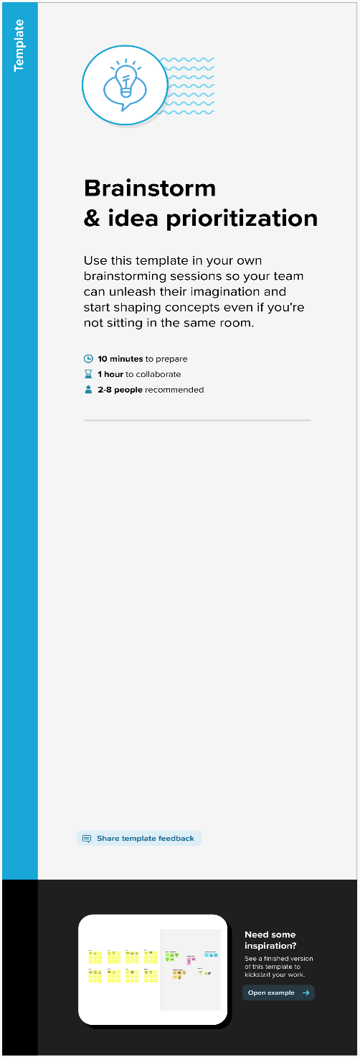 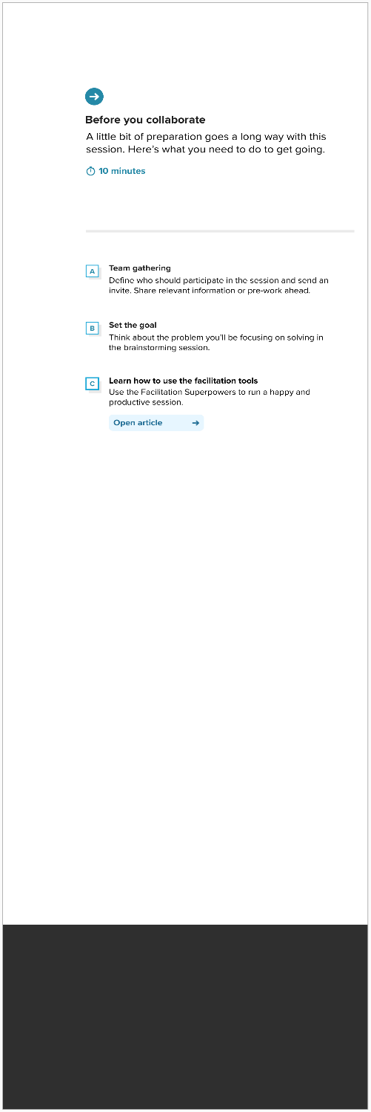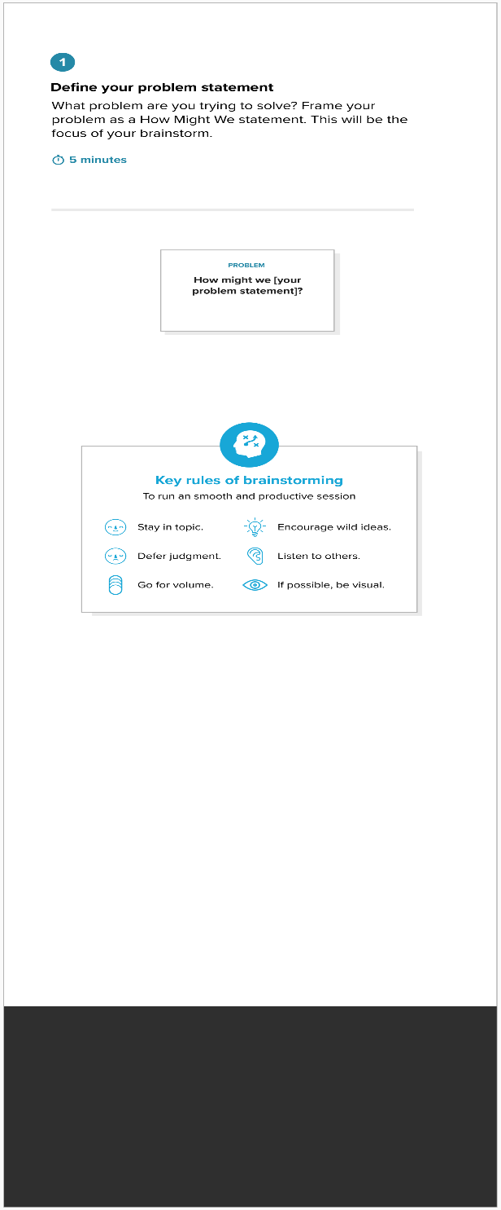

**Step-2: Brainstorm, Idea Listing and Grouping**

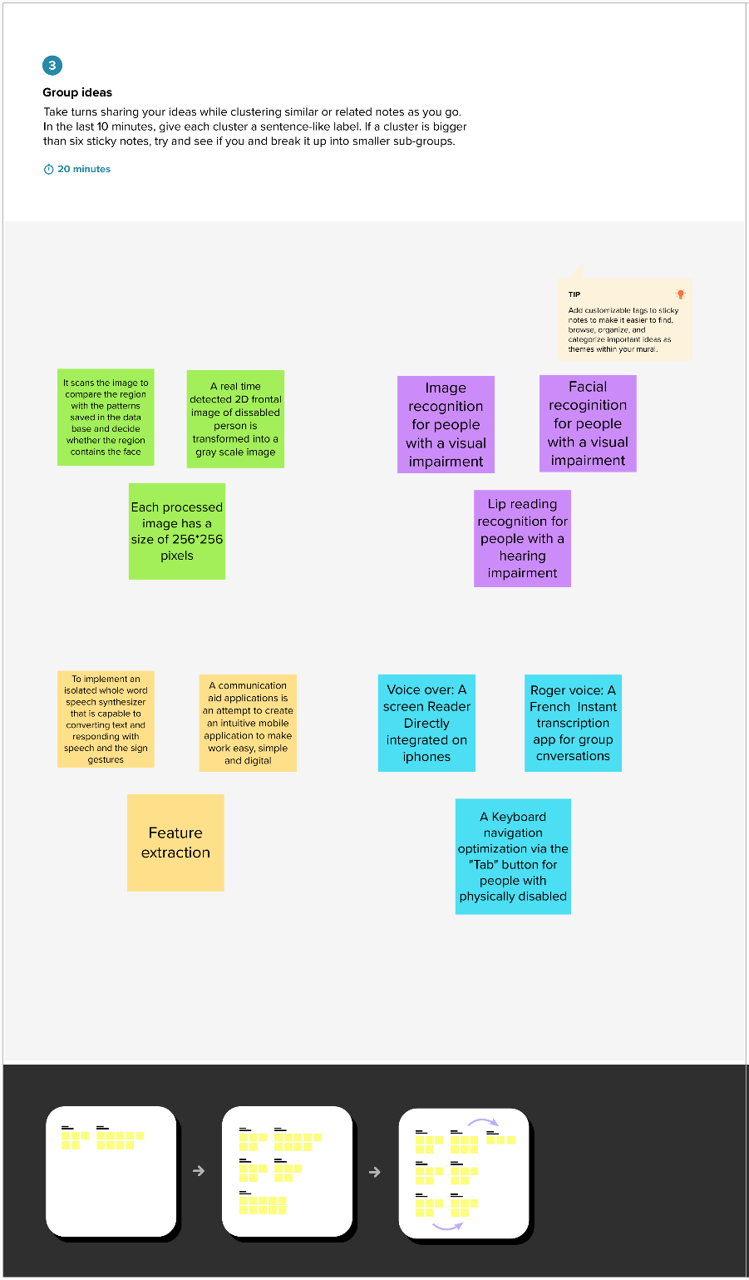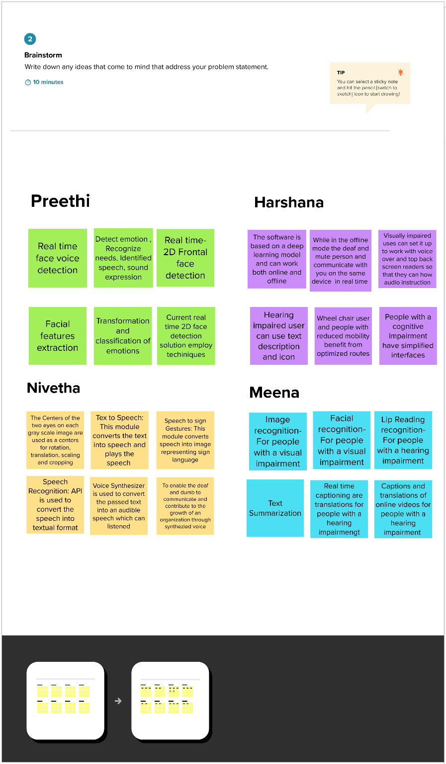

**Step-3: Idea Prioritization**

